

Community Fundraiser to Benefit

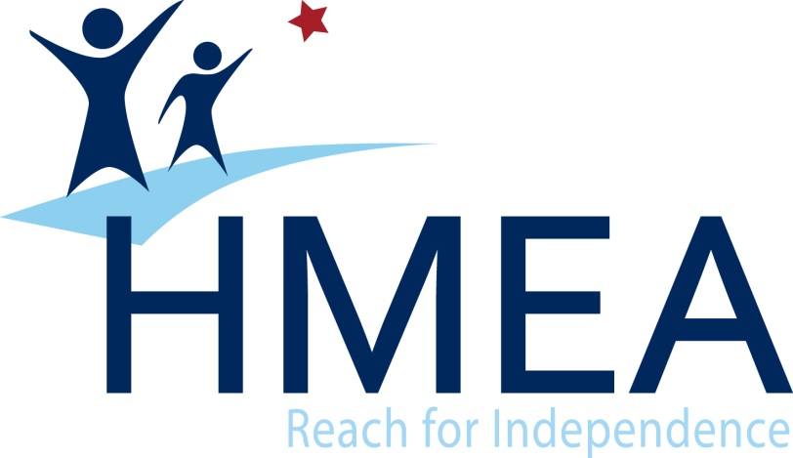

**We will earn 20% of the Sales from our**

**Families & Friends during this time!**

When: Tuesday, April 27, 2021

Time: 3:30 PM – 8:30 PM

Where: 1396 Park Ave, Woonsocket

Phone: 401-762-0390

Valid for Carry Out, Online & Delivery orders!

* When you place your order, tell us you support this fundraiser! Hand us this flyer or show it on a mobile device, in order for your organization to get credit for your order.
* Online orders enter code **19** at the payment screen and then click apply.
* D’Angelo’s will donate 20% of the total pre-tax sales from all the guests that present your flyer during the fundraiser.
* **Fundraiser orders are only valid with regular priced menu items and cannot be paired with coupons or deals.**
* Flyers cannot be handed out in or around the Papa Gino’s restaurant on the day of your event.
* Flyers made by the organization will not be accepted for the fundraiser event.
* **RESTAURANT ONLY - Ring this sale using the POS button 19: Fundraiser.**